ADVENTURE BEFORE DEMENTIA 15

Four months since I last wrote. At that stage we were in Sydney, but we left there beginning of June to head for warmer weather in Queensland. Arrived at Coffs Harbour to discover the Winter Sun Festival on, so lots of rock'n'roll and classic cars for me to drool over again. The women were all dressed in beautiful 50's clothes. I love it and was very tempted to buy a sunfrock, but no room for extras in the caravan. The railway line ran past our caravan park and every few hours a steam train went past and blew it's whistle. Just love the sound of those old trains.
At the beginning of June we watched the Queens Diamond Jubilee. Ten years ago I stood outside Buckingham Palace all day and half the night, with millions of other people, to see the show and fireworks and flyover etc, for her Golden Jubilee. So brought back lots of exciting memories.
Stopped at Ballina again. Had the car serviced and electronics on the transmission (solenoids) replaced as we couldn't start in 1st gear. Cost $570. Then at Caloundra had the rear springs and shock absorbers replaced and that was $1500 so an expensive trip. Dave reckons our car's a money box, so next we'll have a slot cut in the roof.
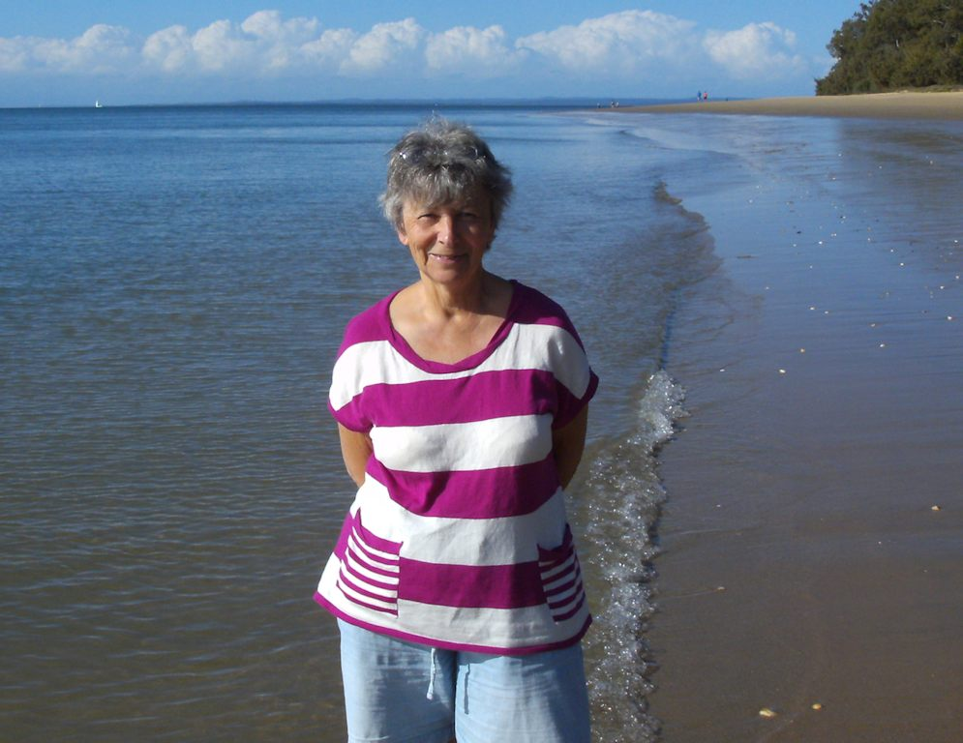
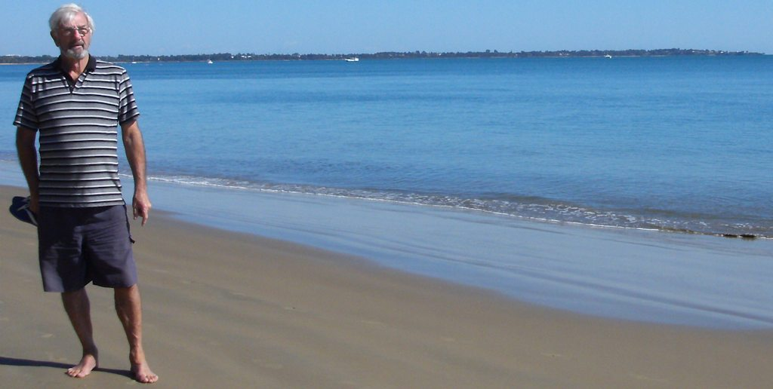
We arrived in Hervey Bay to one of the worst winters they've ever had. During July and even August the temperature sometimes went down to 4 degrees at night, although usually about 20-22 during the day. Actually the winter all over Australia was much colder and wetter than normal. In July, Alice Springs had their coldest 3 days since 1976 and Townsville, Mackay and Rockhampton had their wettest July in 60 years. Must say though, in Hervey Bay, we haven't had rain for over 2 months, so already very dry and the fire danger signs are on High. They keep warning us on TV to watch out for snakes too For me the temperature this month is just about perfect. 12-16 at night and around 25-28 during the day. The beach here is so lovely. Nearly every day there's a cloudless blue sky with beautiful flat turquoise blue water and no waves. (Just look at the photos taken last month of winter in Hervey Bay). We walk along the beach every day and I love taking photos of the patterns in the sand, or the seaweed, coral and shells , or the reflections in the water from the pier. One day there were thousands of jelly fish washed up and every day there are pelicans to watch and twice I've been lucky enough to see a Dugong about 10 metres out eating the seagrass.
At the end of July decided to head up to Darwin, so packed up the van ready to leave the next morning and then went for our final walk along the beach. Dave said 'This is too beautiful to leave, so we've now been in Hervey Bay for 3 months! Couldn't really afford it anyway, as everything is twice the price in the Northern Territory. This is a lovely place to spend the winter and we've met a lot of nice people and made some lovely friends at the caravan park. Spent a few nights playing cards (think we laughed more than we played). Some of them have started their annual migration home to Melbourne and Tasmania for the summer. I've kept busy going to Art classes, a craft group, Tai-Chi and square dancing 3 nights a week. We've finished 8 jig-saws and I've learnt to crochet, so have nearly completed 49 Granny Squares, (just need to put a row of black around each one), then it's ready to bring home and hopefully Bev will help me sew it all together. Also learnt how to cover coat-hangers with lace. At the art classes, guess because I'm so impatient, I like to finish a painting every week (some people are still working on the same one). I've tried oils, acrylics, water colours and pastels. Probably like pastels the best, maybe because my Alsatian dog turned out so good. (had to send a photo to show you).
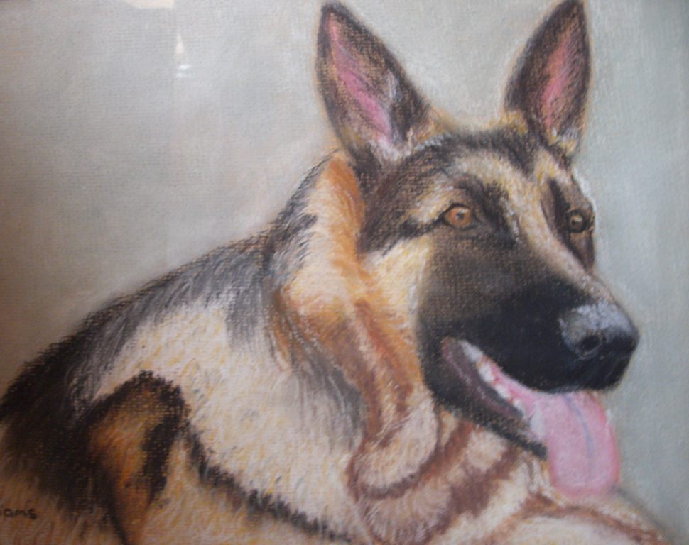
Watched a lot of the Olympic Games, especially the Paralympics. They were excellent. Of course mainly saw the Australian athletes. The commentators were so funny too.
Have been trying to make gluten free biscuits and cakes, but haven't had much success. Never cook properly on the bottom, but hopefully for now I've solved the problem - I'm making uncooked biscuits. Still don't taste half as good as 'normal' biscuits, but that means I don't eat as many, so from that point of view it's great.
Try to Skype the kids every week, but the reception from here is very poor, so the picture is very pixilated and the sound is distorted. Find this very frustrating. I'm sure if we had the top of the range wireless broadband it would make a huge difference. They enjoy getting letters from me, but at $1.90 each it soon adds up, so I sat down one day and wrote 11 letters to each of them, decorated the envelopes with very pretty old stamps that Dave didn't need, then put them all into a parcel with a couple of books and DVDs. Cost $20, so a lot cheaper, and told Lynette to post one in the letterbox every week for them to find. Eloise has her own letterbox in front of her playhouse. Lyn has been very busy digging gardens and planting fruit trees and vegetables, so can't wait to see how it all looks.
Coming home on 5 October for my usual 6 week visit. The first week is school holidays so should be able to spend some time with Ethan. Brent and Simone will be coming up on 12 Oct for a week to further their learning in Akido, so we'll be having Ethan's 8th birthday party a few weeks early this year. Hopefully Bev and I will travel down to the Mount and Rotorua this time and then at the end of Oct, Bev and I are going to New Plymouth for the Rhododendron Festival with Warwick and Lore, so as usual it will be a very busy 6 weeks.

Love Colleen.

